HSS Prev year 2023:

**Management:**

Q. What are the advantage of the managerial grid? Dicuss the advantage & disadvantage of the different channel for transmitting a message?

Ans: The Grid identifies five leadership styles:

Impoverished Management (1,1): Low concern for both production and people

Produce-or-Perish Management (9,1): High concern for production, low concern for people

Middle-of-the-Road Management (5,5): Moderate concern for both production and people

Country Club Management (1,9): High concern for people, low concern for production

Team Management (9,9): High concern for both production and people

The Team Management style is considered to be the most effective leadership style, as it leads to high levels of both productivity and employee satisfaction. The other four styles have their own strengths and weaknesses, and the best style will vary depending on the situation.

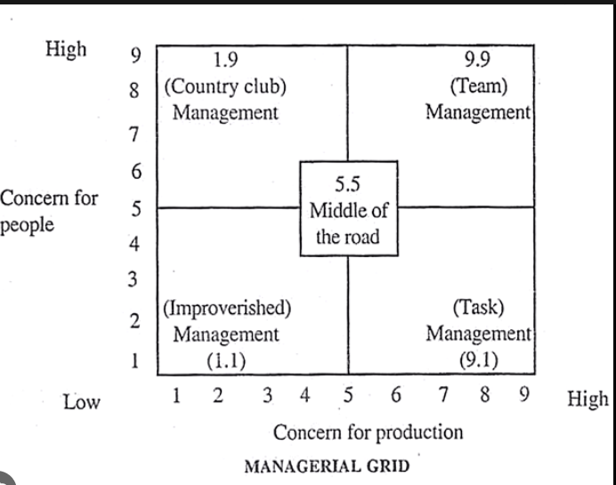

Advantages of the Managerial Grid include:

Provides a simple and easy-to-understand framework for understanding leadership styles.

Helps leaders identify their own leadership style and the style of their subordinates.

Can be used to develop training and coaching programs for leaders.

Can be used to improve communication and collaboration between leaders and their teams.

Advantages and Disadvantages of Different Channels for Transmitting a Message:

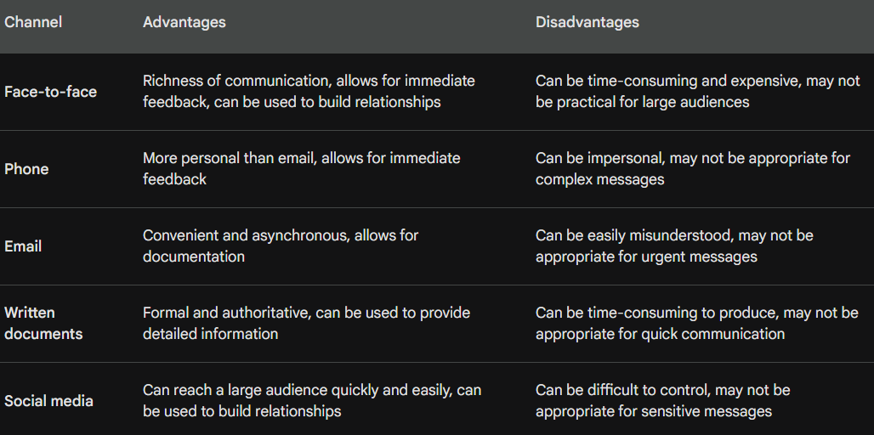

Q. Differentiate between strategies and operational planning? Explain the concept of differentiation strategy with suitable examples?

Ans: **Strategies vs. Operational Planning**

Strategies and operational planning are both important aspects of business management, but they serve different purposes.

**Strategies** are high-level plans that outline a company's overall goals and objectives. They define how a company will achieve its mission and vision. Strategies are typically developed by senior executives and are based on a company's internal strengths and weaknesses, as well as external opportunities and threats.

**Operational planning** is the process of developing detailed plans for how to implement a company's strategies. It involves breaking down strategies into smaller, more manageable tasks and assigning them to specific teams or individuals. Operational plans typically include timelines, budgets, and performance metrics.

**Differentiation Strategies**

A differentiation strategy is a marketing strategy that aims to make a company's products or services stand out from the competition. This can be done by focusing on a particular niche market, offering unique features or benefits, or providing superior customer service.

There are two main types of differentiation strategies:

* **Focused differentiation:** This strategy involves targeting a specific niche market and tailoring the company's products or services to meet the needs of that market. For example, a clothing company might focus on designing clothes for petite women.
* **Broad differentiation:** This strategy involves offering products or services that are different from the competition in a way that appeals to a wide range of customers. For example, a car company might offer a car that is both fuel-efficient and stylish.

**Examples of Differentiation Strategies**

Here are some examples of how companies have used differentiation strategies to achieve success:

* **Apple:** Apple has differentiated itself from other smartphone manufacturers by focusing on design and user experience. The company's iPhones are known for their sleek design and easy-to-use software.
* **Southwest Airlines:** Southwest Airlines has differentiated itself from other airlines by offering low fares and no-frills service. The company does not charge for checked bags or assigned seating.
* **The Body Shop:** The Body Shop has differentiated itself from other cosmetics companies by using natural ingredients and ethical sourcing practices. The company's products are not tested on animals and are made from recycled materials whenever possible.

Q. what conditions encourage a firms to pursue stability strategies? what are different types of expansion strategy?

Ans: Conditions that Encourage Firms to Pursue Stability Strategies

Stability strategies are typically pursued by businesses that are seeking to maintain their current market position and avoid the risks associated with growth. Some of the conditions that may encourage a firm to pursue a stability strategy include:

* Mature market: When a market is mature, there is limited opportunity for growth, and it may be more profitable to focus on maintaining market share rather than trying to expand.
* Strong competitive position: If a firm has a strong competitive position, it may be able to maintain its market share without having to invest heavily in growth initiatives.
* Risk-averse management: Some management teams may be more risk-averse than others and may prefer to avoid the risks associated with growth.
* Economic uncertainty: During times of economic uncertainty, businesses may be more cautious about making investments in growth, as they may be concerned about the potential for a downturn.

Types of Expansion Strategies

There are four main types of expansion strategies:

1. Market penetration: This strategy involves increasing sales of existing products to existing customers. This can be done by increasing marketing efforts, offering new promotions, or expanding distribution channels.
2. Product development: This strategy involves developing new products or services to sell to existing customers. This can be done by researching customer needs, identifying new trends, or leveraging existing technology.
3. Market development: This strategy involves selling existing products to new customers. This can be done by entering new geographic markets, targeting new customer segments, or expanding online sales.
4. Diversification: This strategy involves developing new products or services to sell to new customers. This can be done by entering new industries, acquiring new businesses, or licensing new technologies.

**Finance**

**Leverage** is an essential concept in finance that refers to the use of borrowed capital to amplify potential returns or losses on an investment. It's a tool that allows businesses to increase their purchasing power and expand their operations beyond their existing resources.

**Financial leverage** refers to the use of borrowed capital to increase the potential return on investments. It involves using debt financing, such as loans or [bonds](https://capital.com/bond-definition), to buy [assets](https://capital.com/asset-definition) or invest in projects, which expect to generate higher returns than the cost of borrowing.

Formula: **Financial leverage = Total Debt / Shareholders Equity**

**Operating leverage** refers to the use of fixed operating costs to increase the potential return on investments. It involves using fixed costs, such as rent and salaries, to produce goods or services that could generate higher revenues than the fixed costs.

**Operating leverage = Fixed costs / Total costs.**

**Combined leverage** refers to the use of both financial and operating leverage to increase the potential return on investments. It involves using both debt financing and fixed costs to purchase assets or invest in projects.

**Combined leverage = Financial leverage * Operating leverage.**

**Q. Explain NPV, PBP and IRR?**

Ans: Net Present Value (NPV), Payback Period (PBP), and Internal Rate of Return (IRR) are all commonly used methods for evaluating capital investments.

NPV is the difference between the present value of cash inflows and the present value of cash outflows over a period of time. A project's NPV is calculated by discounting all future cash flows back to their present value using an appropriate discount rate. If a project's NPV is positive, then it is considered to be financially worthwhile. If the NPV is negative, then the project is not considered to be worthwhile.

**NPV** = Σ (Cash flows at time t) / (1 + discount rate)^t

**Payback Period (PBP)**

PBP is the time it takes for a project to recover its initial investment. It is calculated by adding up the cash inflows until the cumulative cash flow equals the initial investment. A shorter PBP is generally considered to be more desirable, as it means that the project will start to generate positive cash flows sooner.

**Here is the formula for PBP:** PBP = Time period + (Initial investment - Cumulative cash flow at end of time period) / Cash flow at end of time period + Cash flow at beginning of next time period

**Internal Rate of Return (IRR)**

IRR is the discount rate that makes the NPV of a project equal to zero. It is the rate of return that an investment is expected to generate. A higher IRR is generally considered to be more desirable, as it means that the project is expected to generate higher returns.

**Here is the formula for IRR:** IRR = Discount rate that makes NPV = 0